Iteration 2

As a shop manager, I want to be able to control appointments and add any relevant information. Each day I want to see what appointments there are and the day before an appointment I want an automated email to send to the parent reminding them of their appointment.

As a developer, I will add this functionality to the program by adding a appointment repository and adding a function within the function that will check the datetime of the appointments and output them if it matches the current date. I need to add a field to each appointment that allows the user to add any relevant information in a ‘notes box.’ I need to add a method that can link to an email account, have a basic structure and can add the unique information needed e.g. the name of the parent.

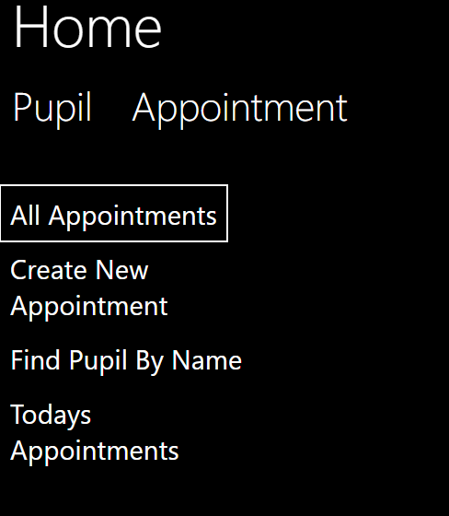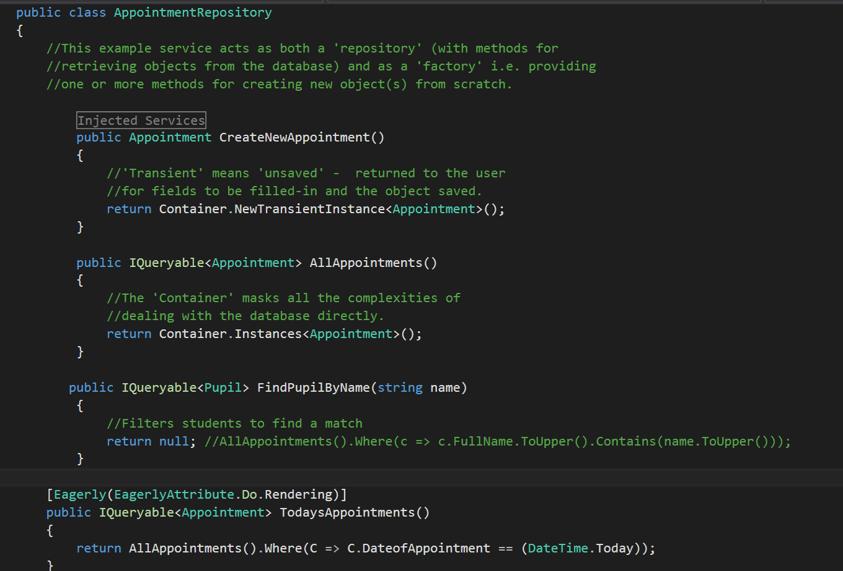

This is the appointment repository. And the list of functions inside of it

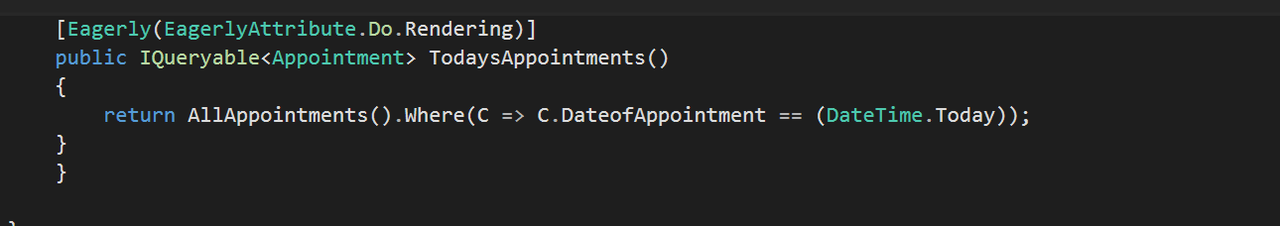

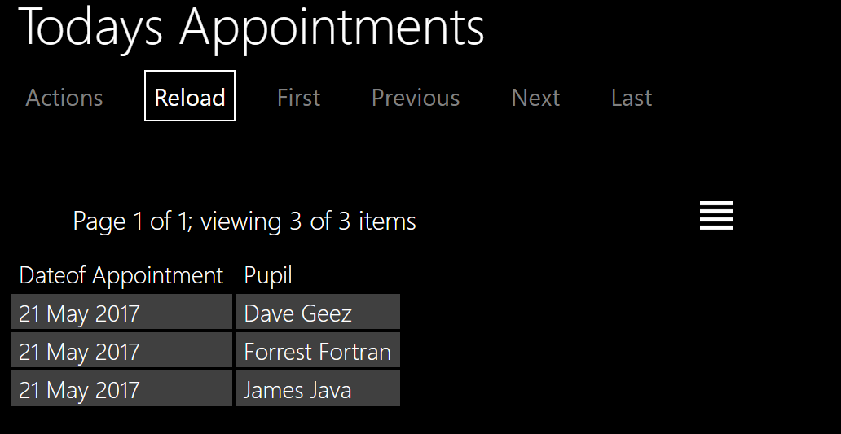

This is the Todays appointments function. This also shows the grid view as default as it shows more information and is more useful in the context.

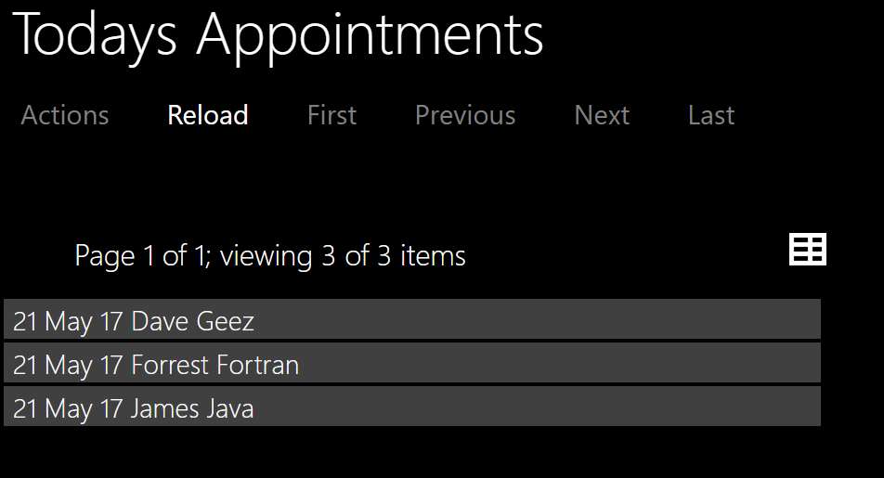

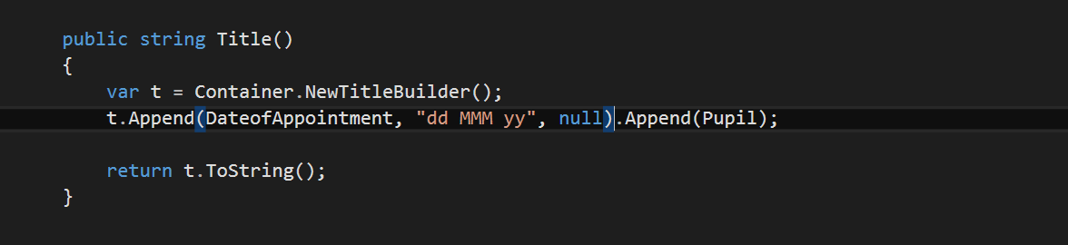

This function has been used to display two pieces of information as the title for each appointment.

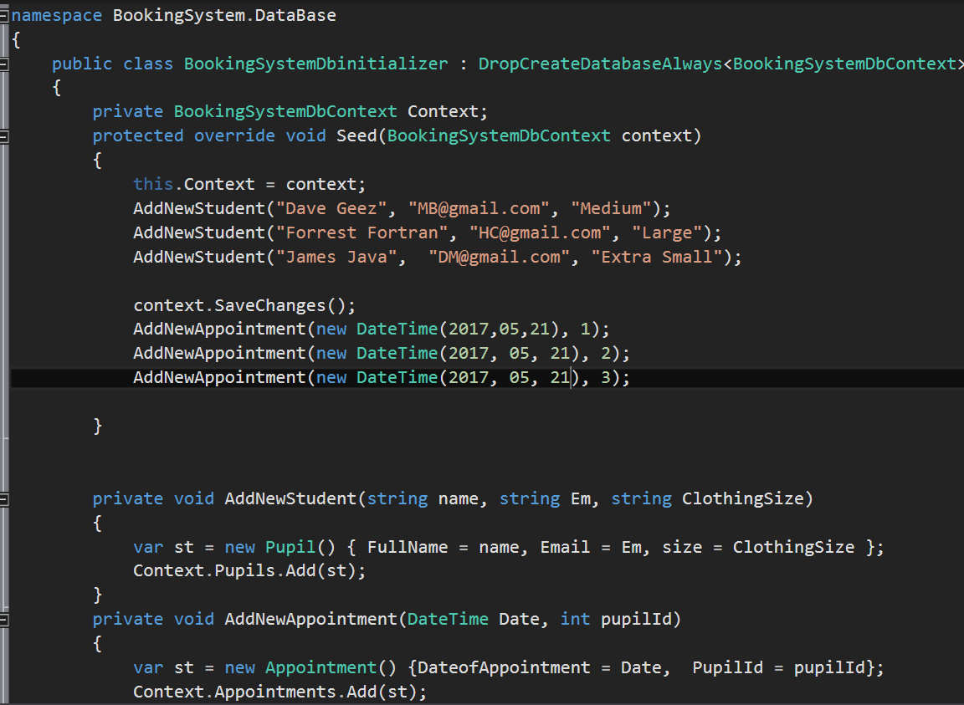

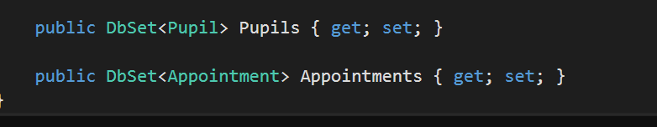

This is the data fixture, I have added example data for appointments and created an id for pupils to maintain the relationship between pupils and appointments in the example data.

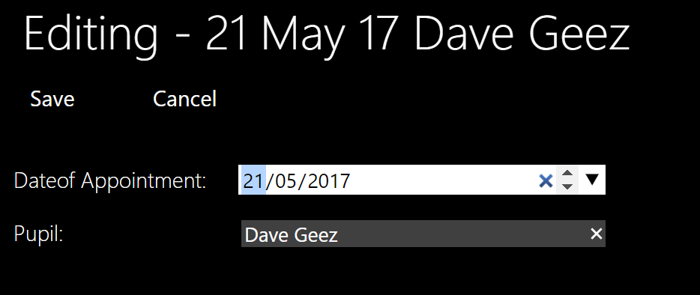

This shows that all appointments and pupils can be edited.

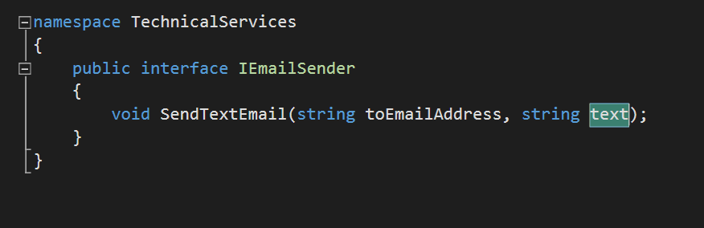

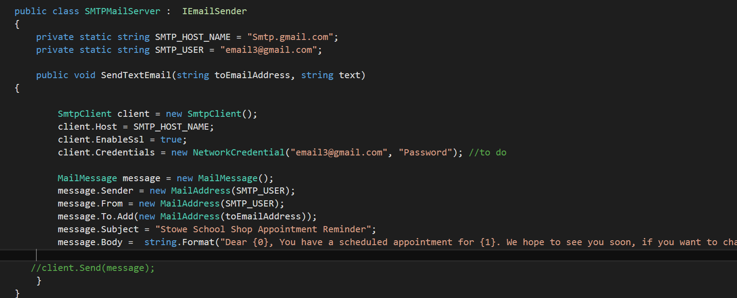

This code can send an automatic email to parents reminding them of their appointment. This can automatically be done each day by using windows task scheduler on the machine.